# **Theory assignment**

## T1(15, 1, 14) T2(20, 2, 26) T3(22, 3)

* First requirement:

F≥max⁡(e(i))  ⟹  F=3F≥max(e(i))⟹F=3

* Second requirement:

H=LCM(15,20,22)=660⟹F={22,20,15,12,11,6,5,4,3,2,1}

* Third requirement:

2*f – gcd(p(i),f) <=D(i)

|  |  |  |  |
| --- | --- | --- | --- |
| f | T1(15, 1, 14) | T2(20, 2, 26) | T3(22, 3) |
| 22 | 44 – gcd(15,22) =  44-1 <=14 (x) |  |  |
| … etc | (x) |  |  |
| 5 | 10 – 5 <=14 | 10 – 5 <=26 | 10-1 <= 22 |

F = 5

## T1(4, 1) T2(5, 2, 7) T3(20, 5)

* First requirement:

F≥max(e(i))⟹F=7

* Second requirement:

H=LCM(4,5,20)=20⟹F={20,10,5,4,2,1}

* Third requirement:

2*f – gcd(p(i),f) <=D(i)

|  |  |  |  |
| --- | --- | --- | --- |
| f | T1(4, 1) | T2(5, 2, 7) | T3(20, 5) |
| 20 | 40 – gcd(4,20) =  44-4 <=4 (x) |  |  |
| … etc | (x) |  |  |
| 4 | 8 – 4 <=4 | 8 – 1 <=7 | 8-4 <= 20 |

F=4 T3 should be divivded into parts T3.1 with e=4 and T3.2 with e=1

## T1(5, 0.1) T2(7, 1) T3(12, 6) T4(45, 9)

* First requirement:

F≥max⁡(e(i))  ⟹  F=9F≥max(e(i))⟹F=9

* Second requirement:

H=LCM(5,7,12,45)=315⟹F={45,35,21,15,12,7,5,3,2,1}

* Third requirement:

2*f – gcd(p(i),f) <=D(i)

|  |  |  |  |  |
| --- | --- | --- | --- | --- |
| f | T1(5,0.1) | T2(7,1) | T3(12, 6) | T4(45, 9) |
| 45 | 90 – gcd(45,5) =  90-5 <=5 (x) | (x) | (x) | (x) |
| … etc | …………………………… |  |  |  |
| 3 | 6 – 4 <=5 | 6– 1 <=7 | 6-3 <= 12 | 6-1<=45 |

F=3 T3 should be divivded into parts T3.1 with e=3 and T3.2

Also T4 should be divivded in to parts T4.1 with e=4 , T4.2 with e=3 and T4.3 with e=3

# ****Simulation assignment****

# Tasks T1(2, 0.5), T2(3, 1.2), T3(6, 0.5) and the RM scheduler

## What is the utilization factor of the system and what is the value for Urm(3) ?

Urm(3) = 0.779 , U=0.73333 U < URM(3) Then it’s feasible

## What is the minimum/maximum/average response time of all tasks?

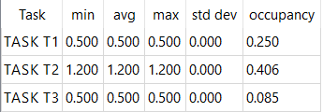

## Is any task missing the deadline? Which task? Where?

No tasks has missed deadline

## If a deadline is missed, could it be avoided by changing the scheduler?

No tasks has missed deadline

* **T1(2, 0.5, 1.9) T2(5, 2) T3(1, 0.1, 0.5) T4(10, 5, 20) and the EDF scheduler**

1. **What is the utilization factor of the system and what is the value for Urm(4) ?**

Urm(4) = 0.7568 , U=1.25 U > URM(4) Then it’s not feasible

1. **What is the minimum/maximum/average response time of all tasks?**

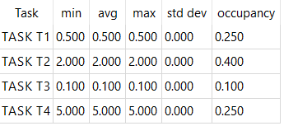

1. **Is any task missing the deadline? Which task? Where?**

Yes task T4 missed the deadline at t={30,40,50,60,70,80,90,100}

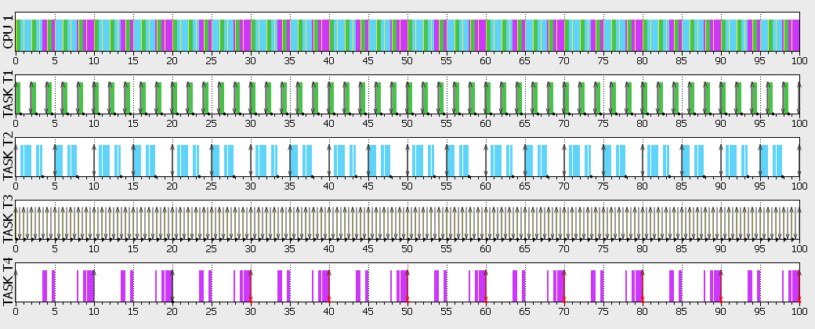

1. **If a deadline is missed, could it be avoided by changing the scheduler?**

No as U > 1 and system is not feasible